**5. Implement programs for estimating & eliminating trend in time series data aggregation, smoothing**

| **EX.N0 : 5** | **Implement programs for estimating & eliminating trend in time series data**  **aggregation, smoothing.** |
| --- | --- |
| **DATE : 29/03/2025** |

**AIM:**

To Implement programs for estimating & eliminating trend in time series data- aggregation, Smoothing.

**PROGRAM:**

import numpy as np

import pandas as pd

import matplotlib.pyplot as plt

from statsmodels.tsa.api import SimpleExpSmoothing

file_path = r""C:\Users\heman\OneDrive\Desktop\abdul\TSA\EX 5\Crude Oil Prices Daily.xlsx") (1)\FINAL_USO.csv" # Update path

df = pd.read_csv(file_path, parse_dates=["Date"], index_col="Date")

df.columns = df.columns.str.strip()

print("Columns in dataset:", df.columns) if "Adj Close" not in df.columns:

print("Error: 'Adj Close' column not found!")

print("Available columns:", df.columns)

exit()

target = "Adj Close"

features = [

'SP_open', 'SP_high', 'SP_low', 'SP_close', 'SP_Ajclose', 'SP_volume',

'DJ_open', 'DJ_high', 'DJ_low', 'DJ_close', 'DJ_Ajclose', 'DJ_volume',

'EG_open', 'EG_high', 'EG_low', 'EG_close', 'EG_Ajclose', 'EG_volume', 'EU_Price', 'EU_open', 'EU_high', 'EU_low', 'EU_Trend',

'OF_Price', 'OF_Open', 'OF_High', 'OF_Low', 'OF_Volume', 'OF_Trend', 'OS_Price', 'OS_Open', 'OS_High', 'OS_Low', 'OS_Trend',

'SF_Price', 'SF_Open', 'SF_High', 'SF_Low', 'SF_Volume', 'SF_Trend',

'USB_Price', 'USB_Open', 'USB_High', 'USB_Low', 'USB_Trend',

'PLT_Price', 'PLT_Open', 'PLT_High', 'PLT_Low', 'PLT_Trend',

'PLD_Price', 'PLD_Open', 'PLD_High', 'PLD_Low', 'PLD_Trend',

'RHO_PRICE', 'USDI_Price', 'USDI_Open', 'USDI_High', 'USDI_Low', 'USDI_Volume', 'USDI_Trend',

'GDX_Open', 'GDX_High', 'GDX_Low', 'GDX_Close', 'GDX_Adj Close', 'GDX_Volume', 'USO_Open', 'USO_High', 'USO_Low', 'USO_Close', 'USO_Adj Close', 'USO_Volume' ]

df = df[[target] + features].dropna()

df["SMA_10"] = df[target].rolling(window=10).mean()

df["SMA_20"] = df[target].rolling(window=20).mean() weights = np.arange(1, 11)

df["WMA_10"] = df[target].rolling(window=10).apply(lambda x: np.dot(x, weights) / weights.sum(), raw=True) exp_model = SimpleExpSmoothing(df[target]).fit(smoothing_level=0.2, optimized=False) df["Exp_Smooth"] = exp_model.fittedvalues

df["Detrended_SMA"] = df[target] - df["SMA_10"]

df["Detrended_WMA"] = df[target] - df["WMA_10"]

df["Detrended_Exp"] = df[target] - df["Exp_Smooth"] plt.figure(figsize=(12, 5))

plt.plot(df[target], label="Original Price", color="blue", alpha=0.5)

plt.plot(df["SMA_10"], label="SMA (10 days)", color="red")

plt.plot(df["Exp_Smooth"], label="Exponential Smoothing", color="black") plt.title("Gold Price Trend Estimation")

plt.xlabel("Date")

plt.ylabel("Price")

plt.legend()

plt.show()

plt.figure(figsize=(12, 5))

plt.plot(df["Detrended_SMA"], label="Detrended (SMA)", color="red") plt.plot(df["Detrended_WMA"], label="Detrended (WMA)", color="green") plt.plot(df["Detrended_Exp"], label="Detrended (Exp Smoothing)", color="black") plt.axhline(y=0, color='gray', linestyle='--')

plt.title("Detrended Gold Price Data")

plt.xlabel("Date")

plt.ylabel("Price Difference")

plt.legend()

plt.show()

**OUTPUT:**

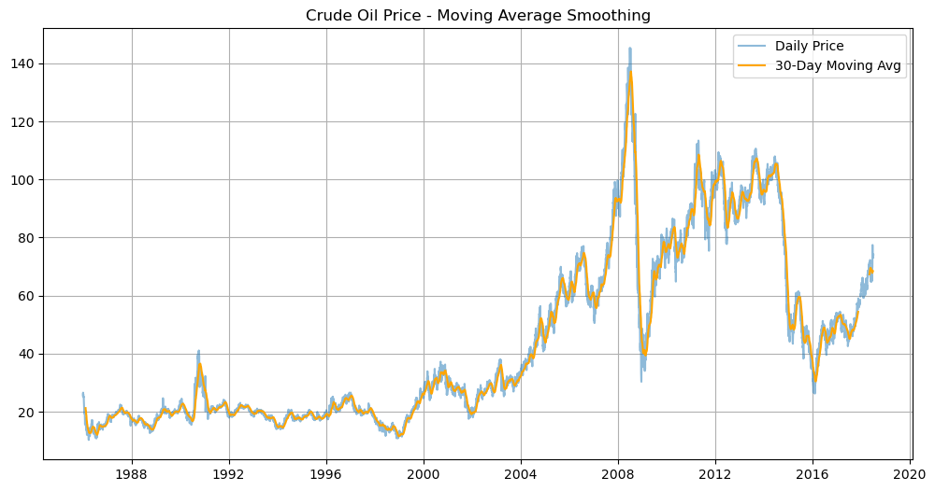**RESULT:**

Thus, the program for Implement programs for estimating & eliminating trend in time series data- aggregation, smoothing is executed successfully.